11.CONFERENCE MANAGEMENT SYSTEM

SEQUENCE DIAGRAM

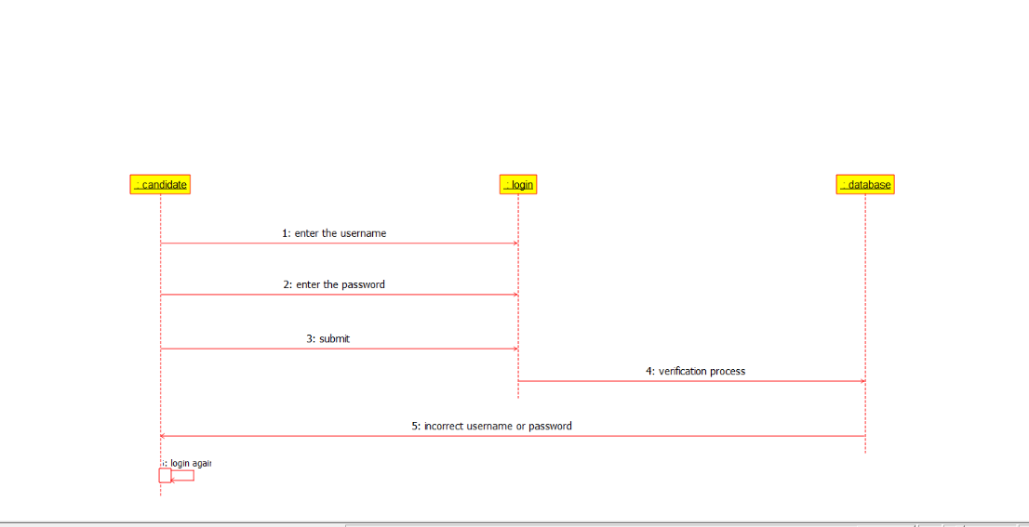

ACTIVITY DIAGRAM

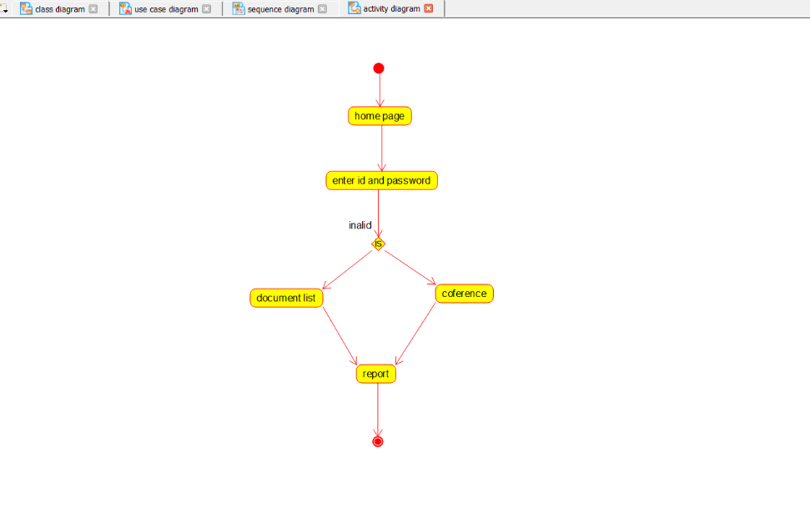

COLLABORATION DIAGRAM

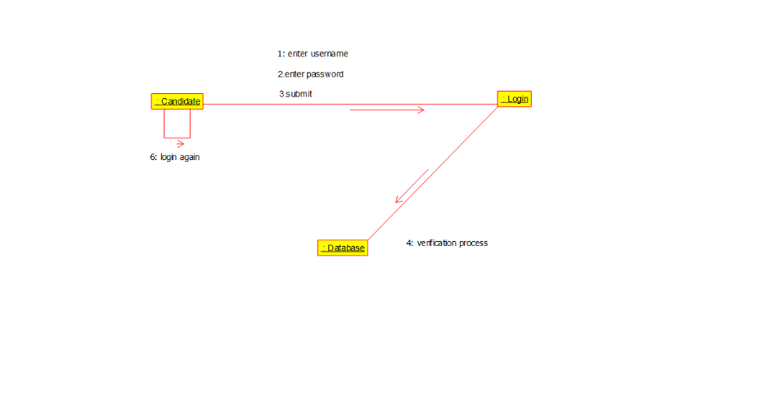

USECASE DIAGRAM

